**Year 8 Chemistry End of Topic Test 2015**

Name:_________________________ Mark: /73

Please cross the one answer you think is most correct.

|  |  |
| --- | --- |
| Question number | Answer |
| 1 | A B C D |
| 2 | A B C D |
| 3 | A B C D |
| 4 | A B C D |
| 5 | A B C D |
| 6 | A B C D |
| 7 | A B C D |
| 8 | A B C D |
| 9 | A B C D |
| 10 | A B C D |

Notice there is a periodic table at the end of this test paper, which may help you.

1. The third shell in an atom holds:

A Up to 18 electrons.

B Up to 2 electrons.

C Up to 8 electrons.

D Up to 20 electrons

2. An atom consists of:

A A nucleus containing neutrons and protons, surrounded by a cloud of electrons.

B Central neutrons, surrounded by a cloud of electrons and protons.

C Central electrons, surrounded by a cloud of protons.

D A mixture of protons and electrons spread evenly in a space.

3. Electrons can be described as having:

A A negative charge and negligible mass.

B A negative charge and huge mass.

C A positive charge and negligible mass.

D No charge.

4. The nucleus of the atom contains

A most of the atoms mass.

B electrons.

C only neutral particles.

D no matter.

5. Analyse the word equation:

methane + oxygen → carbon dioxide + water + energy

This reaction shows that:

A oxygen is a product of this reaction.

B methane burns with a sooty flame.

C this is an exothermic reaction.

D a constant input of energy is required to keep the reaction going.

6. Which of the following would indicate an endothermic reaction.

A a gas is given off

B the reaction glows

C a precipitate forms

D the reaction feels cold to the touch

7. A statement that indicates what the expected result of an experiment will be is called a/an:

A independent variable

B hippopotamus.

C Hypothalamus.

D Hypothesis.

8. Rodney wanted to know if his new fertilizer would make his fruit trees produce more fruit.

He gave 10 tree the new fertilizer. He gave 10 other trees no fertilizer. At the end of the year he measured the Mass of fruit produced. The dependent variable in this experiment was:

A the fertilizer.

B mass of fruit produced.

C type of fruit.

D The number of trees.

9. Which diagram below shows an element?

|  |  |
| --- | --- |
| Name | Diagram showing arrangement of atoms |
| A |  |
| B |  |
| C |  |
| D |  |

10. On the periodic table metal elements are:

A on the left hand side.

B on the right hand side.

C the only elements shown.

D always coloured in red.

1. Use the periodic table supplied to complete table below.

|  |  |  |  |  |  |  |  |
| --- | --- | --- | --- | --- | --- | --- | --- |
| Element | Symbol | Atomic number | Mass Number | Number of electrons | Number of protons | Number of neutrons | Metal or non-metal |
|  | Fe |  |  |  |  |  |  |
| Gold |  |  |  |  |  |  |  |
|  | Cu |  |  |  |  |  |  |
|  | O |  |  |  |  |  |  |
|  | N |  |  |  |  |  |  |
| Neon |  |  |  |  |  |  |  |
|  | C |  |  |  |  |  |  |

(49 marks)

1. I. Draw the electron configuration for oxygen.

(1 mark)

II. Draw the electron configuration for neon.

(1 mark)

III. How many valence electrons does lithium have?

___________________________________________________

(1 mark)

1. I. Label this diagram.

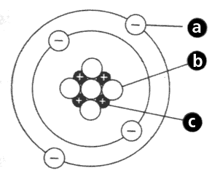

(3 marks)

II. What element is this?

____________________

(1 mark)

1. Electronegativity is a measure of the tendency of an atom to attract electrons. Below is a table showing the electronegativity of Halogens.

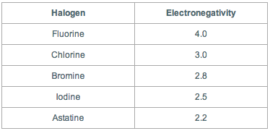

Onto the grid below graph this data in a suitable graph. (5 marks)

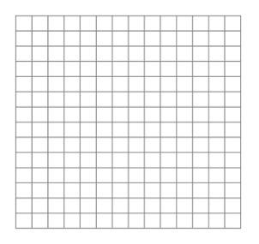

II. What trend can be seen with this group of elements?

_______________________________________________________________________________________________________________________________________________________________________________________________________________________________________________________________________________________

(2 marks)

**Spare graph paper.**

